PHOTOSHOP CHALLENGE - MULTIPLE FILTERS

For this assignment, you will have to ask someone to take a portrait of yourself or you can take a portrait of someone else. You may use a camera, phone, or table to take the photo.

- Using one picture, create 12 identical images lined up on one canvas.

- Open the portrait and crop it to 2" x 3". This will be the image you drag to the new document.

- Choose image; image size and change the resolution of the file to 300; change the width to 2 inches and the height to 3.

- Create a new document in Photoshop sized 8" (width) x 9" (height). This should also have a resolution of 300
- You should have one different filter per image. Each picture and its filter should be on its own named layer.
- Leave the first picture as the original and label it "Original."
- Use the Text tool (in a very small font) to indicate on each picture what filter you have used (bottom right hand corner).
- Save the file in both psd and jpeg formats -- post the jpeg file to the Photoshop page of your Weebly site under the heading “Photoshop Assignment #3 – Multiple Filters”.

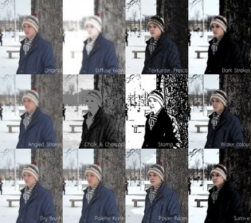
Here is an example of what it should look like:

