PHOTOSHOP CHALLENGE - FILL YOUR HEAD
- Take a profile shot of your head. Use a plain background.
- Duplicate your Background layer.
- On the Background Copy layer, use a selection tool to select only the background (everything but your head/neck/etc.).
- Invert your selection and delete your head:
Select Inverse (delete)
Turn off your original Background layer.
You should now have an image that includes only the background, which shows the outline of where you were in the photo.
- Use a selection tool to re-select the background part. While it is selected, use the brush tool to paint the selection black.
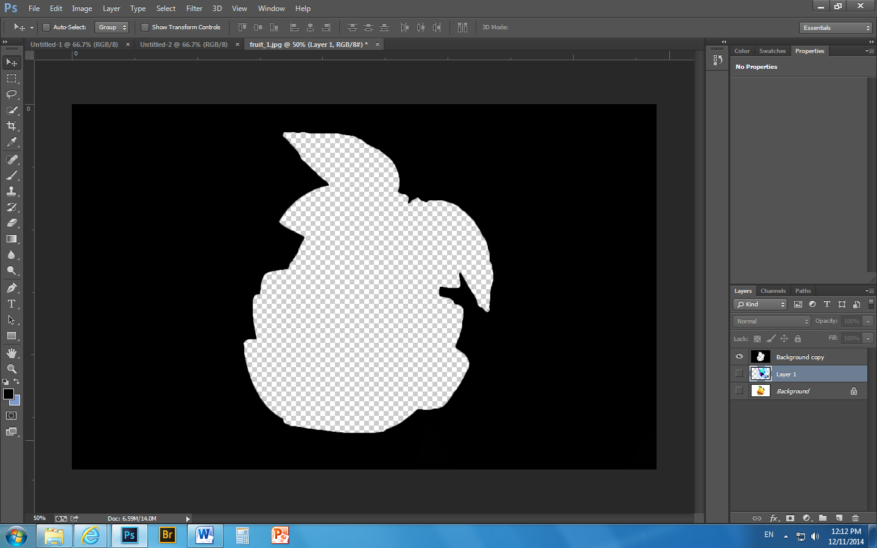
- You are now going to look for images (internet and/or your own photos) that represent you (interests, hobbies, achievements, etc.). Choose a variety of images.
- Put the images in the blank space where you deleted yourself from your photo. Put each item on its own new layer.
- Drag the black outline layer to the top of the layer list.
- Resize items as needed.
- You now have a black outline, with several items “filling” the space where you were in the photo!
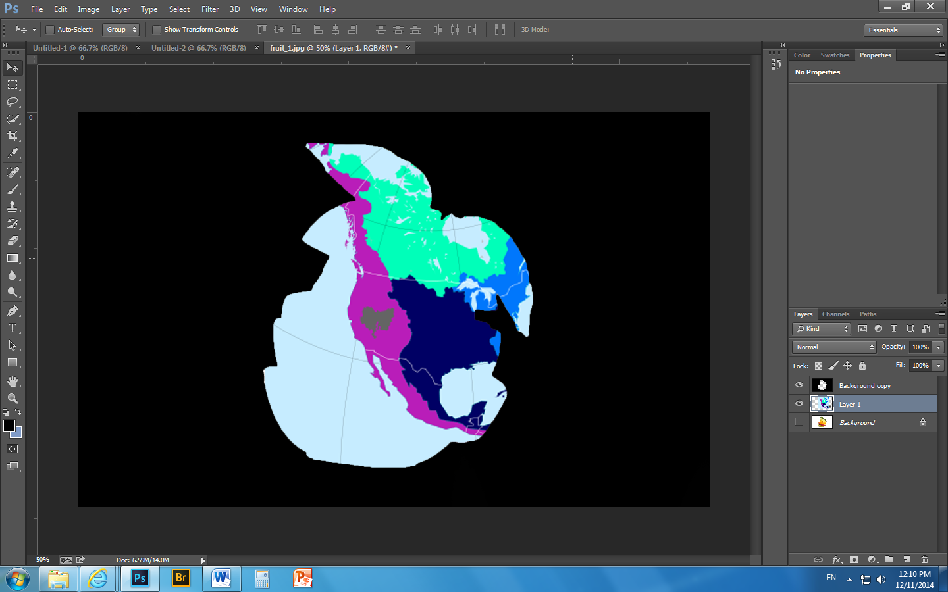
- Add a page border.
- Add a cool text layer with your name.

There are several ways to fill the space in the photo:
A - Open each individual image in Photoshop. Copy and paste each item onto a new
layer on your original document.
B - Drag and drop images straight from the internet.
C - Find a new way!

