PHOTOGRAPHY CHALLENGE – TEXTURE

Choose something that has texture.
- Using a light source in the studio photograph your item in 2 ways:
1 photo: least amount of texture (“flat” lighting)
- photo: most amount of texture possible (will involve shadows!)
- Using a different light source (sunlight, flashlight on phone, lights in the school) photograph your item in 2 ways:
1 photo: least amount of texture (“flat” lighting)
1 photo: most amount of texture possible (will involve shadows!)
Post all 4 photos to your Weebly.
Label your photos:
“Least texture” (also include: aperture, shutter speed, and ISO settings)
“Most texture” (also include: aperture, shutter speed, and ISO settings)
Examples:
MINIMUM TEXTURE (FLAT LIGHTING): MAXIMUM TEXTURE (DEEP SHADOWS):
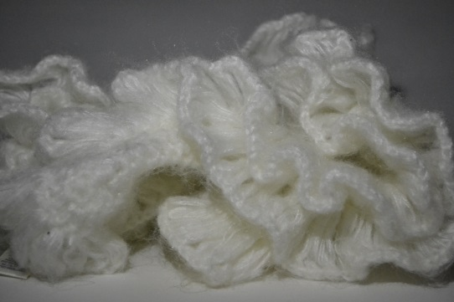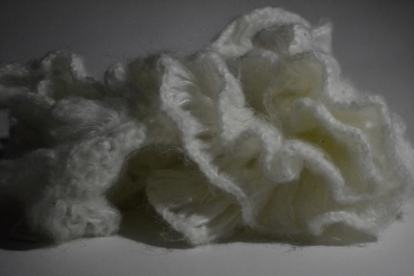
ISO: ___________________________ ISO: ___________________________
Aperture: ______________________ Aperture: ______________________
Shutter Speed: __________________ Shutter Speed: __________________

