PHOTOGRAPHY CHALLENGE – NEGATIVE SPACE

Negative space, sometimes referred to as empty space, is another technique that can be used to give your picture an entirely different atmosphere. The absence of content does not mean the absence of interest. In fact, negative space often adds interest as it can place a stronger emphasis on the subject, and it can evoke emotions effectively. Negative space brings clarity to a photograph. Using this technique correctly can turn empty space into positive space. See the following link and samples below:

https://expertphotography.com/negative-space-photography/
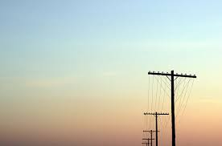

Your Challenge:

Using a camera or your phone, capture four examples of negative space photography. Try to use a variety of examples/backgrounds for your negative space – not all empty sky. Upload the four images to your weebly page under your Photography Assignments tab – no caption required.

