Making your planet

CHOOSING A SUITABLE PHOTO
Virtually any panorama can be turned into a little planet photo, but certain images tend to work better than others. Here are the things you need to consider:
- The viewing angle - 360 degree panoramas work best because their edges line up perfectly, making for a seamless planet photo. Narrower angles can work but you might need to do some work to match colours and textures where the edges meet.
- The sky - Your panorama's sky will be severely distorted in the final image. A clear sky tends to produce the best results, although clouds can give an interesting, stretched effect.
- The ground - The bottom of your photo will be squashed together to form the centre of the planet, and this can lead to some extreme distortion. As with the sky, a flat colour or simple texture such as grass, sand or water looks best.
- The horizon - This needs to be perfectly level so the edges of the picture meet neatly. If yours don't then you can easily crop in Photoshop first.

Got your image? Good. Time to turn it into a planet.

1. MAKE THE IMAGE SQUARE
Because of the way stereographic projections are made, we need to start with a square image. Go to Image > Image Size. Uncheck "Constrain Proportions" and set the height to match the width.
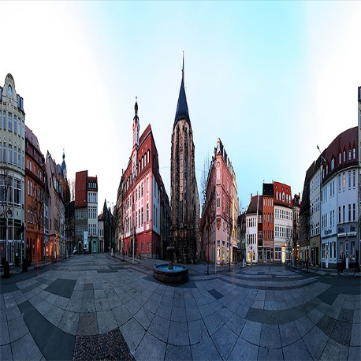
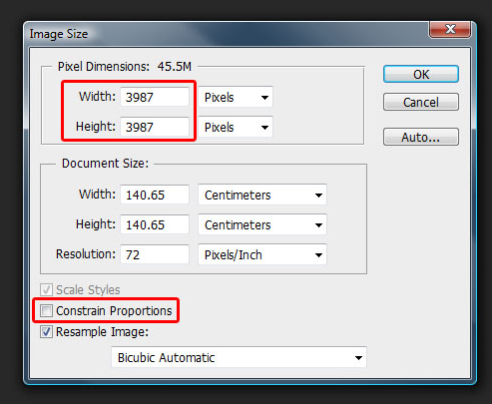

This will squash your image and make it look distorted. Don't worry, this is normal.

2. APPLY A SKY GRADIENT
Ths step is optional but will prevent the corners of the final image looking stretched and warped.
Select the gradient tool and choose the second option (foreground to transparent) and use your colour picker to set an appropriate colour. The colour you choose will be “space”.
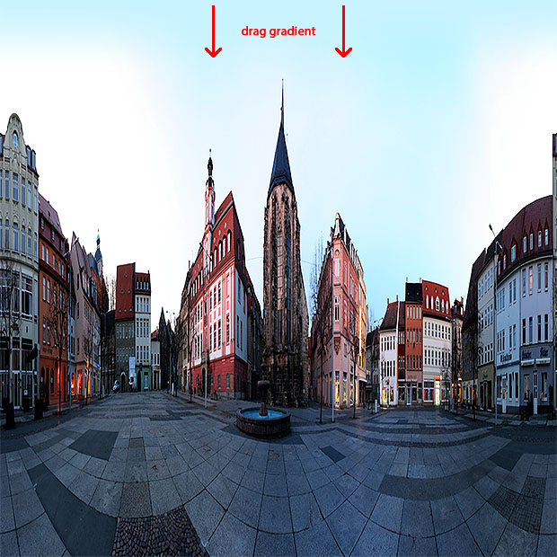

Drag a gradient from the top of your photo downwards a little distance, to produce a smooth transition to the solid colour.

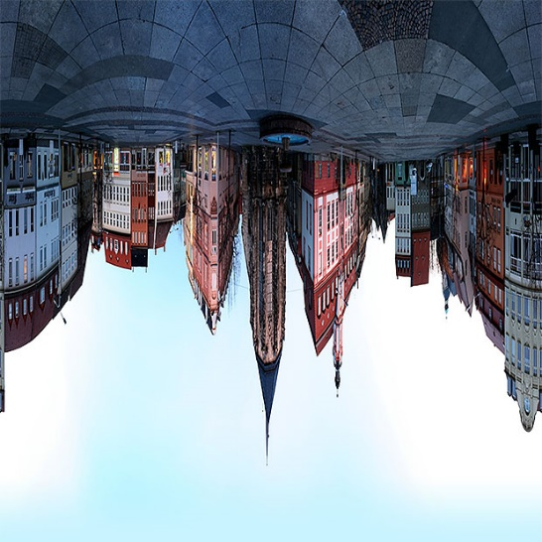

3. TURN THE PHOTO UPSIDE DOWN
Use Image > Image Rotation > 180° to flip your image upside down. This ensures it wraps the right way when we turn it into a planet.

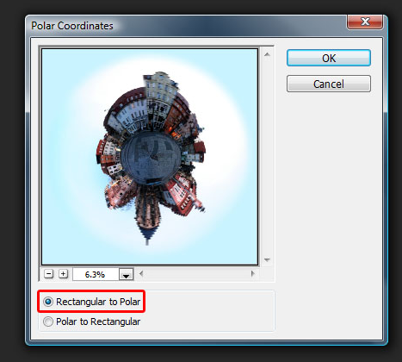
4. APPLY THE POLAR COORDINATES FILTER
Go to Filter > Distort > Polar Coordinates. Make sure "Rectangular to Polar" is selected and hit "OK".

Voilà! Your panorama is now wrapped into a circle and looks like a little planet photographed from above using a fisheye lens.

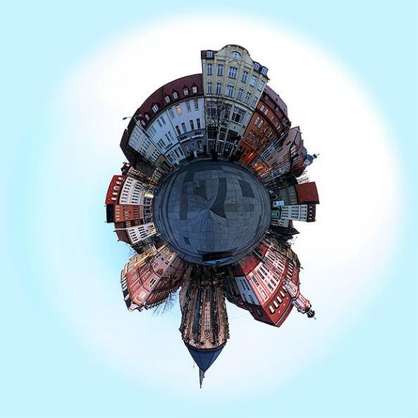
5. FINISHING TOUCHES
Check the upper centre of your photo to make the sure things look smooth where the panorama's edges were joined.
- Use the Clone Stamp or Healing Brush to fix any problems.
- If you'd prefer your planet to be a different way round, now is the time to rotate it.
- Re-crop your image, if necessary, and you're done!
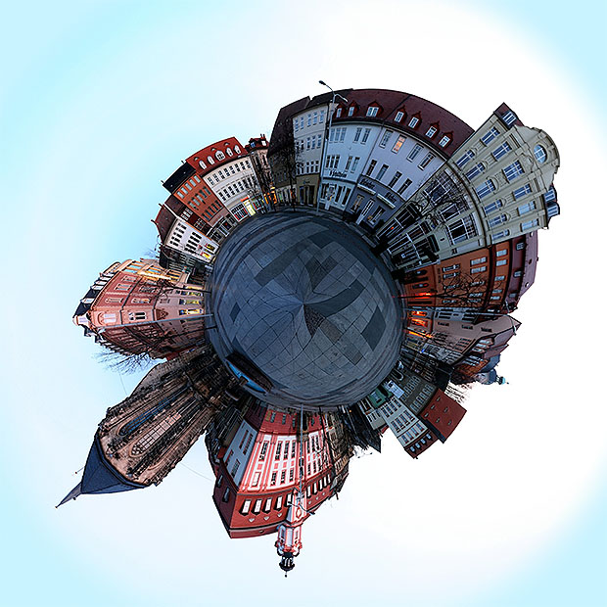
Our finished planet photo.
Creating little planet photos is extremely easy once you get the hang of it. You can produce some fantastic effects by experimenting, so don't feel you have to stick rigidly to the above instructions. If you come across any interesting variations then please share them in the comments.
https://www.photographymad.com/pages/view/little-planet-photos-5-simple-steps-to-making-panorama-worlds

